CMPE679: Deep Learning
Lab 1
Binary Sentiment Classification Using Frozen GloVe Embeddings and a Bidirectional LSTM

Gloria Mbaka
Performed: 2/10/2026
Submitted: 2/12/2026

Instructor: Dr. Liu, Dongfang
TA: Huang, Renzhong; and Renjen, Ishan

By submitting this report, I attest that I neither have given nor have received any unauthorized assistance (including writing, collecting data, plotting figures, tables, or graphs, or using previous student reports as a reference), and I further acknowledge that giving or receiving such assistance will result in a failing grade for this course.
Your Signature: | CGM

1. Abstract
This laboratory investigates the development of a deep neural network for binary sentiment classification using the IMDb movie review dataset. The implemented architecture combines pretrained 300-dimensional GloVe word embeddings with a frozen embedding layer, a bidirectional Long Short-Term Memory network, and dual global pooling mechanisms. The preprocessing pipeline includes normalization, tokenization, vocabulary construction, and fixed-length sequence encoding. The model is optimized using binary cross-entropy with logits and trained using the Adam optimizer. The final trained model achieves 89.08% validation accuracy and approximately 89.03 % test accuracy, with balanced precision, recall, F1-score, and ROC-AUC values. These results demonstrate that contextual sequence modeling combined with pretrained semantic embeddings provides robust performance for sentiment classification.

2. Introduction
Sentiment analysis is a fundamental task in natural language processing that involves determining the polarity of textual content. Unlike structured image data, textual data consists of sequences whose meaning depends heavily on context and word order. Consequently, sequence modeling techniques are required to effectively capture dependencies across tokens.
Recurrent neural networks, and in particular Long Short-Term Memory networks, are designed to handle long-range dependencies by introducing gated memory mechanisms that mitigate vanishing gradients. A bidirectional LSTM extends this capability by processing input sequences in both forward and backward directions, allowing the model to incorporate contextual information from both past and future tokens relative to each position.
The objective of this laboratory was to construct a complete sentiment classification pipeline, beginning with raw textual reviews and culminating in a trained deep neural network capable of high generalization performance. The model integrates pretrained GloVe embeddings to provide semantically meaningful word representations while freezing these embeddings during training to preserve their pretrained structure.

3. Dataset Description
The IMDb dataset contains 50,000 labeled movie reviews evenly divided into training and testing subsets. Each review is associated with a binary label
$$y∈\{0,1\}$$
where $y=0$indicates negative sentiment and $y=1$indicates positive sentiment.
The original training set was partitioned into 20,000 training samples and 5,000 validation samples. The validation set was used to monitor performance during training and to select the best-performing model. The test set, consisting of 25,000 reviews, was reserved strictly for final evaluation.
Each review is represented as a sequence of words
$$x=[w_{1},w_{2},…,w_{T}]$$
where $T$denotes the number of tokens. To ensure uniform input dimensions for batch processing, all sequences were truncated or padded to a maximum length of $T=200$. This length was chosen as a balance between preserving sufficient contextual information and maintaining computational efficiency.

4. Text Preprocessing and Vocabulary Construction
Text preprocessing plays a critical role in transforming raw natural language into a format suitable for neural network input. All reviews were converted to lowercase to eliminate case-based duplication in the vocabulary. HTML artifacts such as line breaks were removed to prevent artificial token inflation. Non-alphanumeric characters were eliminated while preserving apostrophes to retain meaningful contractions. Excess whitespace was normalized.
Stopwords were removed using the NLTK English stopword list. However, negation terms such as “not,” “no,” and “don’t” were deliberately retained because negations significantly alter sentiment polarity. Removing negations could lead to incorrect classification of phrases such as “not good.”
A vocabulary of size 50,000 was constructed using only the training dataset. This prevents leakage of information from validation or test samples. Two special tokens were introduced:
$$\text{PAD}=0 \\ \text{UNK}=1$$
The padding token ensures consistent sequence length, while the unknown token handles out-of-vocabulary words.
After tokenization and indexing, each review was encoded as
$$x∈N^{200}$$
where integer values correspond to vocabulary indices.

5. Pretrained Word Embeddings
Pretrained GloVe embeddings with 300 dimensions were incorporated to represent words in a semantically meaningful vector space. Each word $w$is mapped to
$$e(w)∈R^{300}$$
The embedding matrix is defined as
$$E∈R^{V×300}$$
where $V=50,000$.
Approximately 83.43% of vocabulary words were matched to pretrained GloVe vectors. Words not present in the pretrained dataset were initialized with small random values drawn from a normal distribution to maintain numerical stability.
The embedding corresponding to the padding token was explicitly set to the zero vector
$$e(\text{PAD})=0$$
The embedding layer was frozen during training, meaning
$$\frac{∂L}{∂E}=0$$
Freezing the embedding layer reduces the number of trainable parameters and stabilizes early training while preserving semantic relationships learned from large corpora.

6. Model Architecture

6.1 Input Representation
For batch size $B$, the input tensor is
$$X∈R^{B×200}$$
After embedding lookup,
$$E(X)∈R^{B×200×300}$$
Thus, each review becomes a sequence of 200 word vectors of dimension 300.

6.2 Bidirectional LSTM
The model employs a bidirectional LSTM with hidden dimension $H=128$. At each timestep $t$, the forward and backward hidden states are given by
$$\vec{h_{t}},\overset{⃖}{h_{t}}∈R^{128}$$
The concatenated representation is
$$h_{t}=[\vec{h_{t}};\overset{⃖}{h_{t}}]∈R^{256}$$
The full LSTM output tensor is
$$H_{\text{out}}∈R^{B×200×256}$$
This representation captures contextual information from both directions.

6.3 Global Pooling
To convert the sequence of hidden states into a fixed-length vector, both global max pooling and global average pooling were applied across the temporal dimension.
Global max pooling is defined as
$$h_{\text{max}}=\overset{200}{\underset{t=1}{max⁡}}H_{\text{out}}$$
Global average pooling is defined as
$$h_{\text{avg}}=\frac{1}{200}\sum_{t=1}^{200}{H_{\text{out}}}$$
Both vectors lie in $R^{B×256}$. They are concatenated to form
$$h_{\text{concat}}∈R^{B×512}$$
This combined representation captures both the strongest activation patterns and the overall contextual distribution.
The final logit is computed as
$$z=Wh_{\text{concat}}+b$$
where $W∈R^{1×512}$.

7. Training Procedure
Binary cross-entropy with logits was used as the loss function:
$$L=-\left[ylog⁡(σ(z))+(1-y)log⁡(1-σ(z))\right]$$
where the sigmoid function is
$$σ(z)=\frac{1}{1+e^{-z}}$$
Optimization was performed using the Adam algorithm with learning rate ${10}^{-3}$. Training was conducted for six epochs. The best validation performance was achieved at epoch three.
During evaluation, the model was switched to evaluation mode and gradient computation was disabled to prevent updates from validation or test data.

8. Results and Analysis
The best validation accuracy achieved was $89.08\%$.
The final test accuracy was approximately $89.03\%$.
Precision was approximately 0.8919, recall was approximately 0.8882, and the F1-score was approximately 0.8901. The ROC-AUC score was approximately 0.9571, indicating strong ranking performance.
Training loss decreased steadily across epochs (Figure1). Validation loss decreased until epoch three and then began to plateau, suggesting mild overfitting beyond that point. Selecting the checkpoint with the highest validation accuracy mitigated overfitting effects.
The confusion matrix yielded (Figure 2):
True Negatives: 11,154
False Positives: 1,346
False Negatives: 1,397
True Positives: 11,103
These values indicate balanced classification performance across both classes.
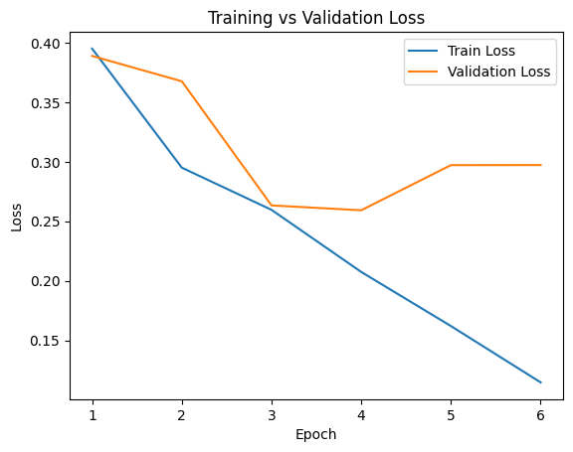
Figure 1: Training and Validation Loss Across Epochs
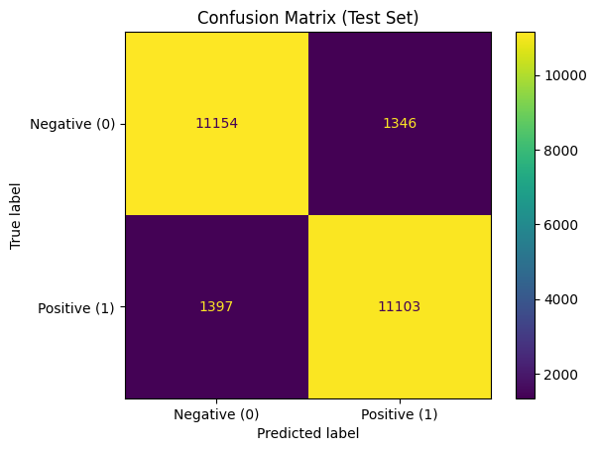
Figure 2: Confusion Matrix

9. Conclusion
This laboratory implemented a complete deep learning pipeline for binary sentiment classification using pretrained GloVe embeddings and a bidirectional LSTM architecture with temporal pooling. The model achieved approximately 89% test accuracy, exceeding expected performance thresholds. The integration of contextual sequence modeling with pretrained semantic representations proved effective for sentiment analysis. The combination of contextual modeling and dual pooling captured both local and global sentiment cues. Mild overfitting was observed in later epochs, but selecting the best validation checkpoint mitigated performance degradation.

10. Questions

Q1: Feedback on Lab
The lab effectively introduces NLP in PyTorch. A clearer explanation of vocabulary-to-embedding alignment would reduce confusion. Providing a small dataset class template would also assist beginners.

Q2: Additional Evaluation Metrics
Precision was used to measure the proportion of predicted positives that were correct. Its limitation is sensitivity to class imbalance.
Recall was used to measure how many actual positives were correctly identified. Its limitation is that it does not penalize false positives.
F1-score balances precision and recall but does not capture ranking behavior.
ROC-AUC was used to evaluate performance across classification thresholds. Its limitation is reduced interpretability in highly imbalanced datasets.

11. AI Usage Disclosure

Artificial intelligence tools were used to support learning, clarify deep learning concepts, debug implementation issues, and assist in organizing the written report. All code was written, executed, and verified by me, and all results were generated from my own implementation.

References
[1] J. Pennington, R. Socher, and C. D. Manning, “GloVe: Global Vectors for Word Representation,” in Proceedings of the 2014 Conference on Empirical Methods in Natural Language Processing (EMNLP), Doha, Qatar, 2014, pp. 1532–1543.
[2] S. Hochreiter and J. Schmidhuber, “Long Short-Term Memory,” Neural Computation, vol. 9, no. 8, pp. 1735–1780, 1997.
[3] M. Schuster and K. K. Paliwal, “Bidirectional Recurrent Neural Networks,” IEEE Transactions on Signal Processing, vol. 45, no. 11, pp. 2673–2681, 1997.
[4] A. Maas, R. Daly, P. Pham, D. Huang, A. Ng, and C. Potts, “Learning Word Vectors for Sentiment Analysis,” in Proceedings of the 49th Annual Meeting of the Association for Computational Linguistics, 2011, pp. 142–150.
[5] D. P. Kingma and J. Ba, “Adam: A Method for Stochastic Optimization,” in Proceedings of the 3rd International Conference on Learning Representations (ICLR), 2015.
[6] A. Paszke et al., “PyTorch: An Imperative Style, High-Performance Deep Learning Library,” in Advances in Neural Information Processing Systems 32, 2019.

